Feedback

Overall it’s looking really good. Thank you Alex.

New fonts and layout detail

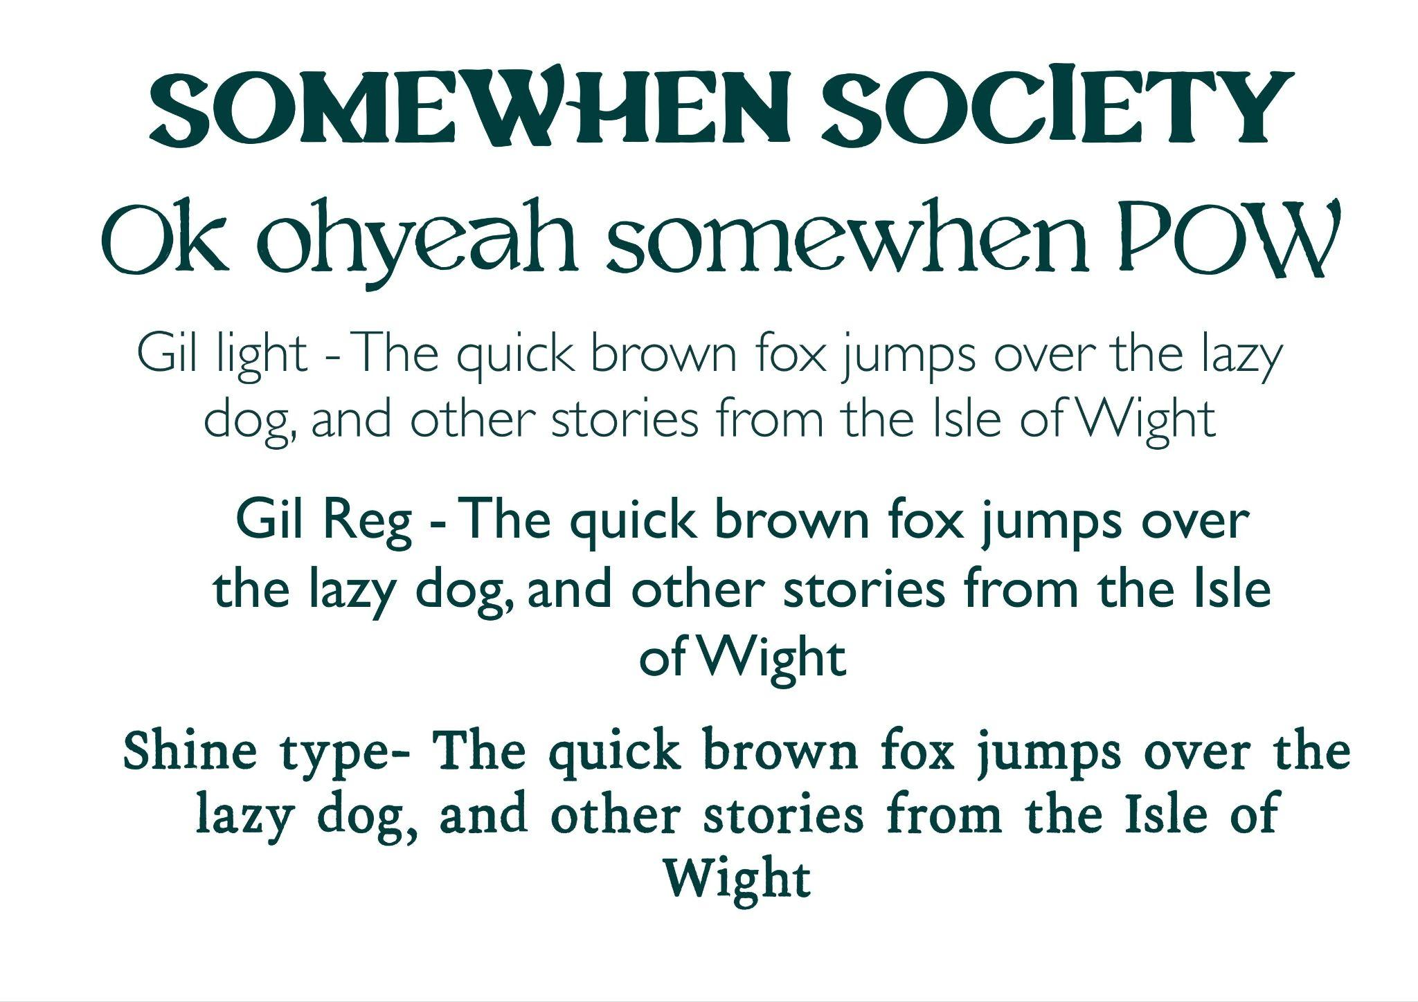

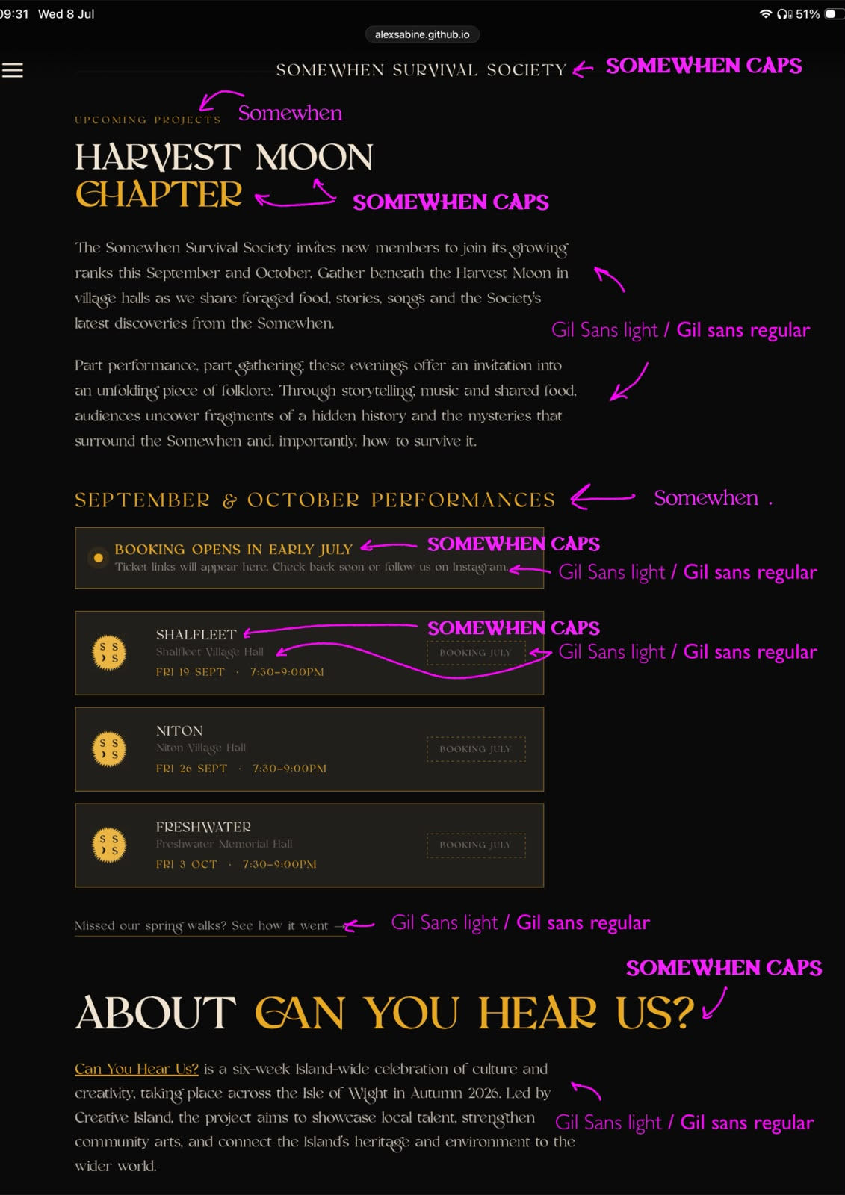

-Button to link to Instagram account

-Even number of images in gallery to make completed lines of images.

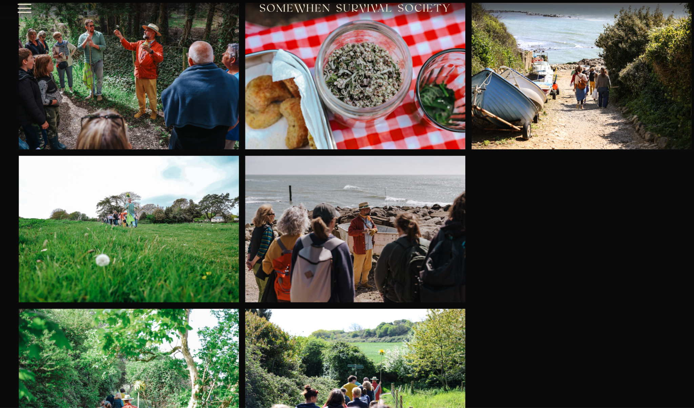

Edit Home Page

Remove the ‘about project’ section.

About the Project
The Harvest Moon Chapter: A Living Myth, A Foraged Feast
Through foraging walks, shared food, ritual and live performance, we invite participants to step into a piece of unfolding folklore, one in which they are not the audience alone, but are invited to become members.

Straight to Upcoming Events

Amended copy for ‘About Us’ page

Somewhen Productions is an arts organisation dedicated to creating world-class immersive cultural events specifically within the Isle of Wight community. We operate through our creative collective, The Somewhen Survival Society, a new reimagining of ancient ideas making work rooted in the Island's landscape. As living myth-makers, we are dedicated to revitalising rural culture and combating rural isolation through theatrical storytelling, local folklore, and innovative arts events. Our work fosters place-pride and connects residents across generations.

The Somewhen Survival Society was formally established in December 2025, and it is built upon decades of creative, cultural and community leadership on the Isle of Wight and beyond.
The company brings together four directors with complementary expertise in theatre-making, design, producing and organisational leadership.
Peter Higgin, an immersive arts practitioner and former Artistic Director of Punchdrunk Enrichment, brings extensive experience in participatory theatre, community engagement and cultural leadership. Alongside his artistic practice, Peter serves as Chair of Governors for the Cornerstone Federation and Chair of the Board of Ventnor Exchange.
Designer Sean Turner has played a significant role in shaping the Island's creative landscape through his work with The Department in Ryde and the Horse Box Theatre Company, creating opportunities for artists and audiences alike.
Samuel Wyer, an Olivier-nominated designer, and Clementine Seely, an internationally experienced creative producer, previously collaborated on the critically acclaimed Forest Fables at Mottistone Manor. Created in partnership with the National Trust, the production provided a much-needed COVID-secure cultural experience for Island audiences in 2020 and was described as "utterly charming".
Together, the directors combine international experience with deep local knowledge and a shared commitment to creating ambitious, community-rooted work that celebrates the stories, landscapes and people of the Isle of Wight.

The ‘Can You Hear Us?’ festival has brought us together to create this new theatre company through which we will deliver world-class, site-specific storytelling and events that celebrates local culture, folklore and landscape, ensuring that rural communities young and old remain at the heart of the Island's cultural narrative.

Upcoming Events amended copy

The Harvest Moon Chapter
The Somewhen Survival Society invites new members to join its growing ranks this September and October.
Gather beneath the Harvest Moon in village halls across the Isle of Wight as we share foraged food, stories, songs and the Society's latest discoveries from the Somewhen.
Part performance, part feast, part gathering, these intimate evenings offer an invitation into an unfolding piece of Island folklore. Guided by members of the Society, audiences will uncover fragments of a hidden history, encounter curious traditions, and learn the survival skills passed down by those who have ventured closest to the Somewhen.
As the evening unfolds, the boundary between our world and the myth of the Somewhen begins to blur.
This unique theatrical experience invites you to step inside a living mythology and discover what it takes to survive the Somewhen.

